Ref.: UCVLLP/BOM/9696 Date: 28/01/2026

VALUATION OF IMMOVABLE PROPERTY
(FORM- 01)

Valuation of the property being Commercial Shop no. 34, Ground Floor, Vartak Nagar Shopkeepers Premises Co-op. Soc. Ltd., Pokran Road no. 1, Vartak Nagar, Thane (W)-400606.
PART - I
GENERAL
1 | Purpose for which valuation is made
2 | Date as on which valuation is made
3 | Name of Current Property owner/ Name of Borrower
4 | If the property is under joint ownership/ Co-ownership, share of each owner. Are the shares undivided?
5 | Location, Street, Ware No./Sector
6 | Survey/Plot No. of land
7 | Is the property located in residential/ Commercial/mixed area/Industrial area
8 | Classification of locality-high class/ Middle class/ low class
9 | Proximity to civic amenities like schools, hospitals, offices, market, cinema, railways, etc.
10 | Means and proximity to surface  communication by which locality  is served

LAND
11 | Roads, streets or lanes on which the land is abutting
12 | Is it freehold or leasehold land
13 | If leasehold, the name of lessor /lessee, nature of lease, date of commencement and termination of lease and lease of renewal of lease
 | i | Initial Premium
 | ii | Ground rent payable per annum
 | iii | Unearned increase payable to lessor in the event of sale or transfer
14 | Is there any restrictive covenant in regard to use of land? If so, attach a copy of the covenant
15 | Are there any agreements of easements?
16 | If so, attach copies
17 | Does the land fall in an area included in any Town Planning Scheme, or any Development Plan of Government or any Statutory body? If so, give particulars.
18 | Has the whole or part of the land notified for acquisition by Government or any other statutory body? Give date of notification. |  | No.
19 | Attach a dimensioned site plan

IMPROVEMENTS

20 | Attach plans and elevations of all structures standing on the land and a layout plan
21 | Furnish technical details of the building on a separate sheet.
22 | i | Is the Unit owner occupied/ tenants/or both?
 | ii | If partly owner occupied, specify portion and extent of area under owner occupation
23 | What is the floor space index permissible and percentage actually utilized.

RENTS

24 | i | Names of tenants / lessees / licensees
 | ii | Portions in their occupation
 | iii | Monthly or annual rent /compensation/ license fee, etc., paid by cash.
25 | Are any of the occupants related to or close business associates of owner
26 | Is separate amount being recovered for the use of fixtures, like fans, geysers, refrigerators, cooking ranges, built-in cupboards, etc., or for service charges? If so, give details.
27 | Give details of water and electricity charges if any, to be borne by owner
28 | Has the tenant to bear the whole or part of the cost of repairs and maintenance? Give particulars
29 | If a lift installed, who has to bear the cost of maintenance and operations, owner or tenants?
30 | If a pump is installed, who has to bear the cost of maintenance and operation, owner or tenant?
31 | Who has to bear the cost of electricity charges for lighting of common spaces like entrance hall, stairs, passage, compound, etc. Owner or Tenant?
32 | What is the amount of Property Tax? Who is to bear it? Give details with documentary proof
33 | Is the building insured? If so give Policy No., Amount for which it is ensured and The annual premium.
34 | Is any dispute between landlord and tenant regarding rent pending in a court of law?
35 | Has any standard rent been fixed for the premises under any law relating to the control of rent?
SALES
36 | Give instances of sales of immovable property in the locality on a separate sheet indicating the name and address of the property, registration no., sale price and area of land sold.
37 | Property rate adopted in the valuation
38 | If sale instances are not available or not relied upon, the basis for arriving at rate.

ANNEXURE TO FORM 0-1
TECHNICAL DETAILS

1 | No. of floors, Type of Unit and height of each floor
2 | Plinth Area of the Premises
3 | Year of Construction
4 | Estimated future life
5 | Type of Construction – load bearing walls/ RCC frame / Steel frame
6 | Type of foundations
7 | Walls
 | I |  | Basement and plinth
 | Ii |  | Ground Floor
 | Iii |  | Superstructure
8 | Partitions
9 | Doors and windows (floor-wise)
10 | Flooring
11 | Finishing (Floor-wise)
12 | Roofing and Terracing
13 | Special architectural or decorative features, if any.
14 | I | Internal wiring- surface or conduit
 | ii | Class of fitting- superior / ordinary / poor
15 | Compound Wall
16 | No. of Lifts
17 | Roads and Pavements within the compound approx. area and type of paving
18 | Sewage disposal – whether connected to public sewers, if septic tank provided No. and capacity
19 | Latitude & Longitude

Property is bounded by:

Landmark –

Areas Considered for Valuation:

As per physical measurement the carpet area of shop comes to 124 sq.ft. As per agreement for sale Carpet area of shop is 100 sq.ft. after considering 20% loading on carpet area the built-up area of shop comes to 120 sq.ft., which is considered for valuation.

Factors considered for valuation :
Location & locality, facilities & amenities, quality of construction, residual life of building, business potential, supply & demand, local nearby enquiry, market feedback of investigation & Ready Recknor published by Government.

Documents referred for Valuation:
We referred the Xerox copy of following documents provided to us for valuation purpose:
- Old Valuation Report no. V/02/2013/02694 dated 11/02/2013 issued by M.M. Vaidya (Govt. Approved Valuers).
- Index-II bearing no. 5931/2007 dated 13/11/2007
- Agreement for sale dated 12/11/2007 between Mr. Purushottam Sampat Pal (Vendor) and Mr. Vinod Ghisulal Chaudhary (Purchaser).
- Receipt no. 1968 dated 14/1/2006 issued by Vartak Nagar Shopkeepers Premises Co-op. Soc. Ltd. in the name of Shri. Sudam K. Jadhav.
- Society registration certificate dated 24/01/1972.
- Property Tax for year 2005 bearing receipt no. 017311 dated 19/07/05 issued by TMC to Vartak Nagar Shopkeepers.

PART – II
VALUATION
(Calculations, discussions and approach of valuation)

Under instructions from Bank of Maharashtra, Vartak Nagar-Thane Branch, we have referred the documents of the Commercial Shop no. 34, Ground Floor, Vartak Nagar Shopkeepers Premises Co-op. Soc. Ltd., Pokran Road no. 1, Vartak Nagar, Thane (W)-400606, with a view to ascertain the fair market value of the property.

The said property is located within a locality comprising predominantly of commercial premises. Civic amenities like shops, restaurants, schools, post office, bank, etc., are located nearby and within easy reach from this property. The property comprises of middle class families and 4 kms. away from Thane railway station. The property was constructed in the year 1972.

As per agreement for sale Carpet area of shop is 100 sq.ft. after considering 20% loading on carpet area the built-up area of shop comes to 120 sq.ft., which is considered for valuation. While looking at the market rate for Vartak Nagar, Thane-West area, it was found that the rate for similar properties goes between Rs. 33,000/- to Rs. 36,000/- per sq.ft. on Built-up area. Hence, considered a fair rate of Rs. 35,000/- sq.ft. on Built-up area for the said property.

Fair Market Value of property = 120 sq.ft. X Rs. 35,000/- sq.ft. = Rs. 42,00,000/-
(Rupees Forty Two Lakhs Only)

Summary of Valuation:
Fair Market Value :
Realizable Value (10% less) :
Forced/Distress Sale Value (20% less) :
Insurance Value (120 sq.ft x Rs. 1,500/- sq.ft) :
Ready Reckoner Value (120 sq.ft. x Rs. 17,484/- per sq.ft.) :

This is in my opinion is a Fair Market value of the above described Commercial Shop as on date.

Remark:
- We have finalized the report on the basis of site visit and copy of: Notarised MOU, Previous Agreement for sale, C.C, O.C, Floor Plan, Title Report, Share Certificate, etc. However, we have not been provided with latest registered Agreement/Index-II, Approved plan, etc. for verification purpose.
- The subject property was owner occupied at the time of inspection.
- Name board such as “Bhawani Jewellers” was displayed at site.
- Toilet units are constructed outside the unit.
- Property is situated in residential cum commercial area.
- The value given is considering all the surrounding area & locational advantage of the said property.
- Property is inspected as shown by person met on site Mr. Vinod Chaudhary-Owner (9892561425)
- We consider the area given in the Agreement for sale, declared by the party and submitted for registration with the government authorities as final for valuation purpose. Any area that is not stated in the Agreement for sale is not considered for valuation unless the area is measured by us in which case that may be considered for valuation purpose.
- The scope of our valuation work is only for banks financial/loan purpose. Further, please be noted that this report shall not be used for any litigation purpose.
- Encumbrance of Loan, Government and other dues, stamp duty, registration charges, transfer charges etc, if any are not considered in the valuation. We assumed that the assets are free from encumbrance unless otherwise stated to us by the party in writing.
- The value given in our report is the estimate of the Fair Market value of the property as on date, considering various aspects of the property as mentioned above.

DECLARATION-CUM- UNDERTAKING
- I Mr. Manoj Kumar Sharma do hereby solemnly affirm and state that
  - I am a citizen of India.
  - I will not undertake valuation of any assets in which I have a direct or indirect interest or become so interested at any time during a period of three years prior to my appointment as valuer or three years after the valuation of assets was conducted by me.
  - The information furnished in my valuation report date 28/01/2026 is true and correct to the best of my knowledge and belief and I have made an impartial and true valuation of the property.

Our representative Mr. Rahul Karande inspected the property on 22/01/2026.
  - Valuation report is submitted in the format as prescribed by the Bank.
  - I have not been depanelled/ delisted by any other bank and in case any such depanelment by other banks during my empanelment with you, I will inform you within 3 days of such depanelment.
  - I have not been removed/dismissed from service/employment earlier
  - I have not been convicted of any offence and sentenced to a term of imprisonment
  - I have not been found guilty of misconduct in professional capacity
  - I have not been declared to be unsound mind
  - I am not an undischarged bankrupt, or has not applied to be adjudicated as a bankrupt;
  - I am not an undischarged insolvent.
- I have not been levied a penalty under section 271J of Income-tax Act, 1961 (43 of 1961) and time limit for filing appeal before Commissioner of Income tax (Appeals) or Income-tax Appellate Tribunal, as the case may be has expired, or such penalty has been confirmed by Income-tax Appellate Tribunal, and five years have not elapsed after levy of such penalty.
- I have not been convicted of an offence connected with any proceeding under the Income Tax Act 1961, Wealth Tax Act 1957 or Gift Tax Act 1958 and
- I undertake to keep you informed of any events or happenings which would make me ineligible for empanelment as a valuer.
- I have not concealed or suppressed any material information, facts and records and I have made a complete and full disclosure
- I have read the Handbook on Policy, Standards and procedure for Real Estate Valuation, 2011 of the IBA and this report is in conformity to the “Standards” enshrined for valuation in the Part-B of the above handbook to the best of my ability. I have read the International Valuation Standards (IVS) and the report submitted to the Bank for the respective asset class is in conformity to the “Standards” as enshrined for valuation in the IVS in “General Standards” and “Asset Standards” as applicable.
- I abide by the Model Code of Conduct for empanelment of valuer in the Bank. (Annexure V- A) signed copy of same to be taken and kept along with this declaration) t. I am registered under Section 34 AB of the Wealth Tax Act, 1957.
- I am valuer registered with Insolvency & Bankruptcy Board of India (IBBI).
- My CIBIL Score and credit worthiness is as per Bank’s guidelines.
- I am the proprietor authorized official of the firm, who is competent to sign this valuation report.
- I will undertake the valuation work on receipt of Letter of Engagement generated from the system (i.e. LLMS/LOS) only.
- Further, I hereby provide the following information.
- If this format if found changed than it is done as per the requirement of the respective branches. If nothing is heard within 15 days from the date of this report then it is presumed that the valuation report is accepted by the bank in to to. To accept or reject our valuation report is sole discretion of the Bank as well the quantum of loan amount disbursement to your customers on the basis of our valuation will be decided by the bank and we are not held responsible for any changes in the market rates in the future, including becoming NPAs of any properties due to any reason whatsoever.
- Whilst we have taken the opportunity of looking through the documents (whatever available) it is recommended that the relevant documents are subjected to formal legal inspection in order to ensure that there are no elements, restriction or charge contained which are likely to have detrimental effect upon the valuation provided.

(MANOJ KUMAR SHARMA)
Govt. Valuer & Chartered Engineer
Panel Valuer of Bank of Maharashtra
(IBBI/RV/07/2019/11044)
Place: Thane
Date: 28/01/2026

Photographs

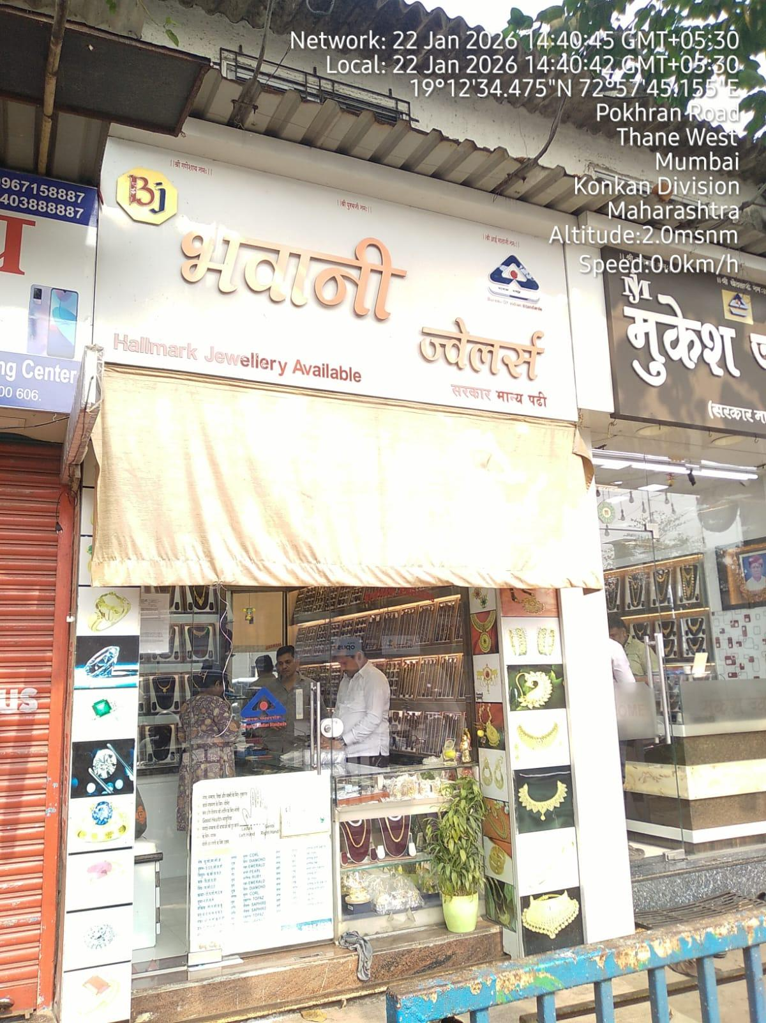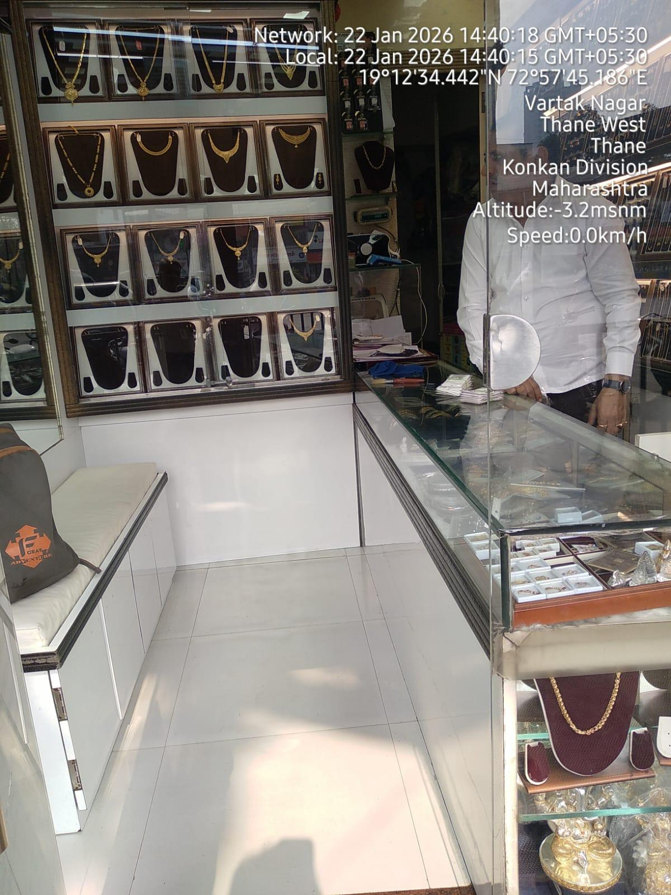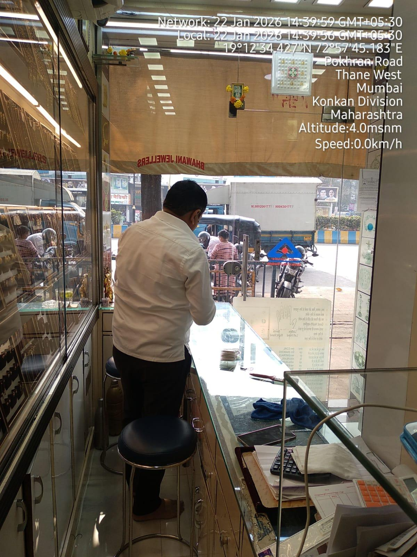

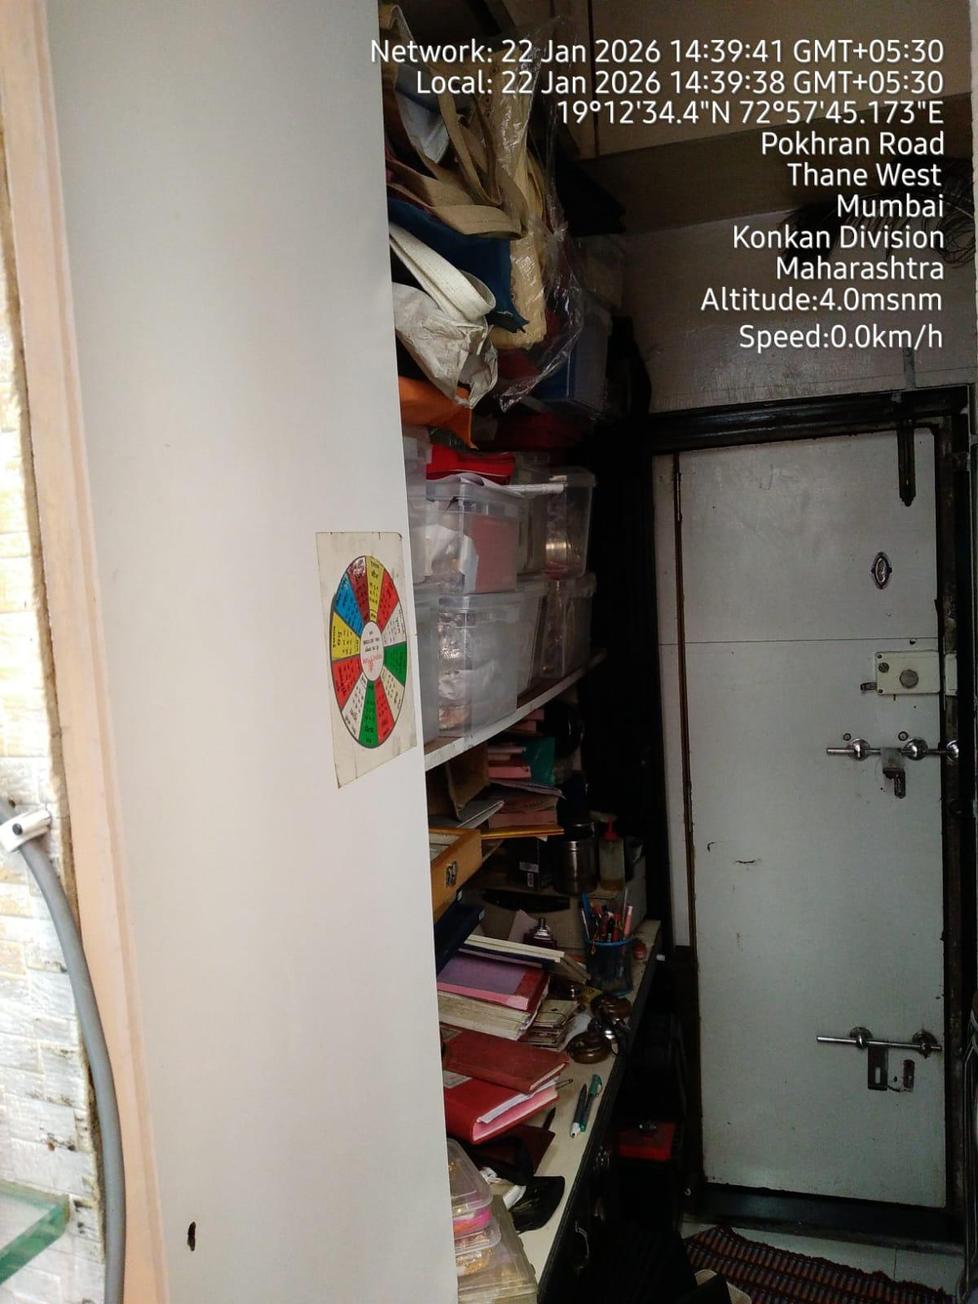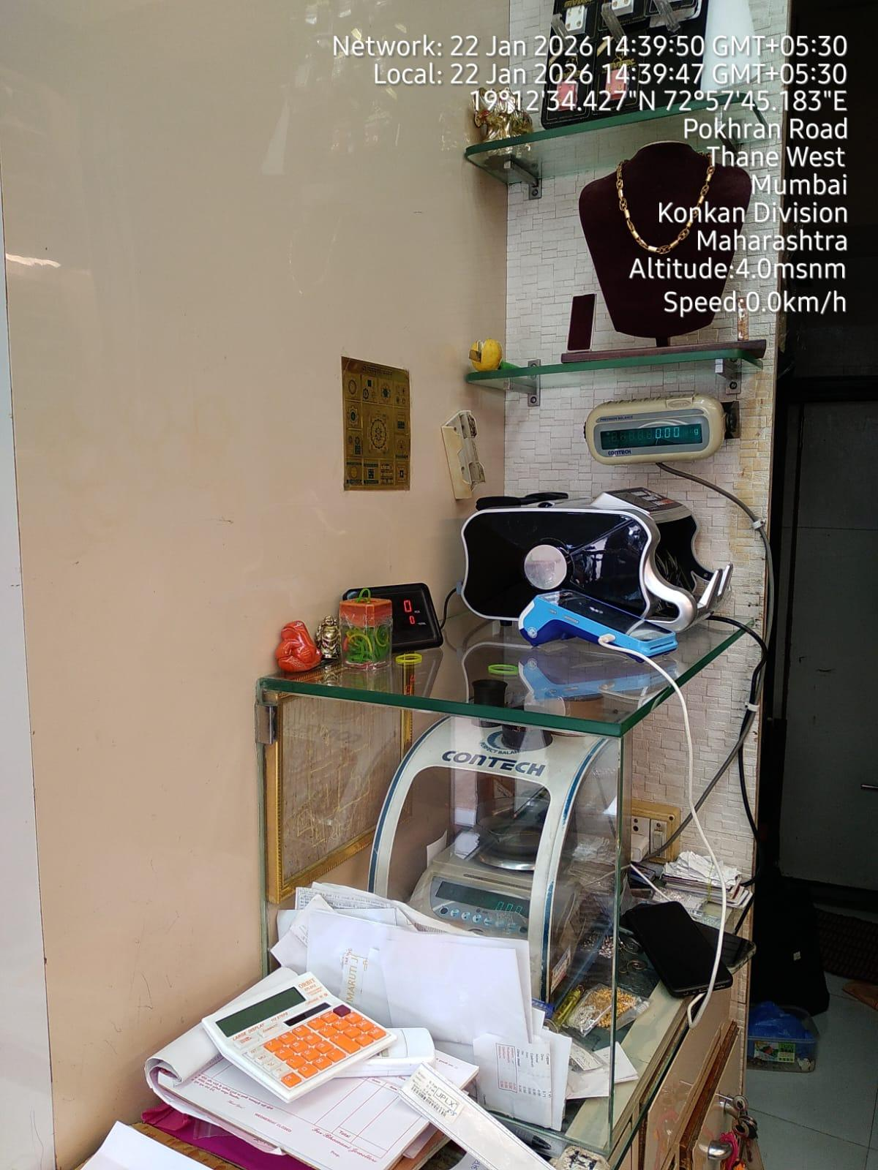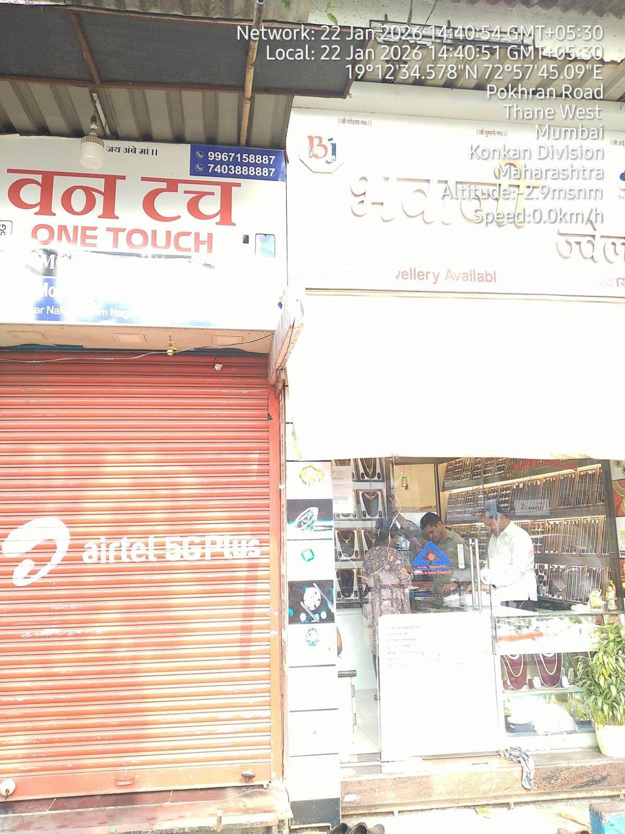

Location Map
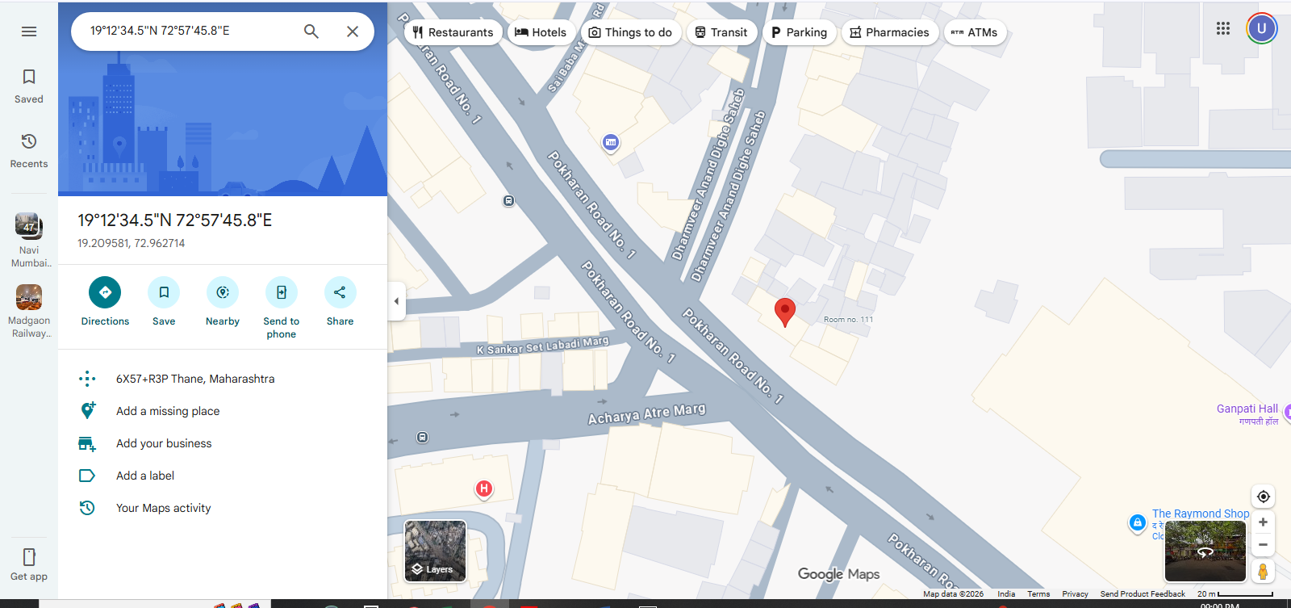

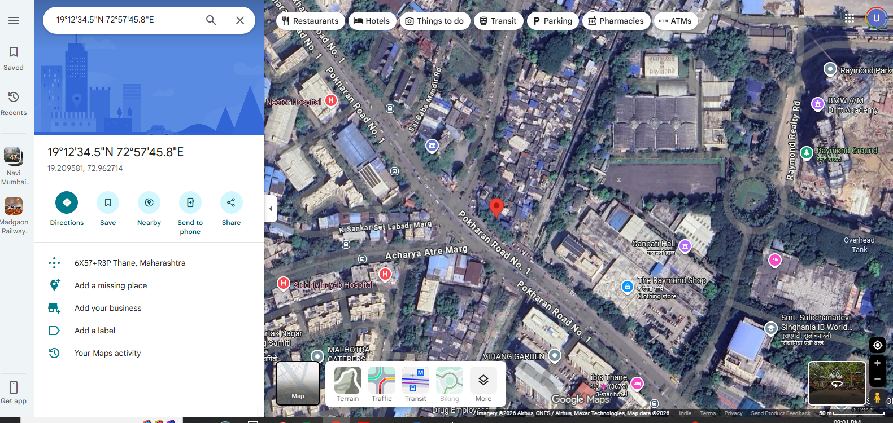

Ready Reckoner Rates 2025-2026

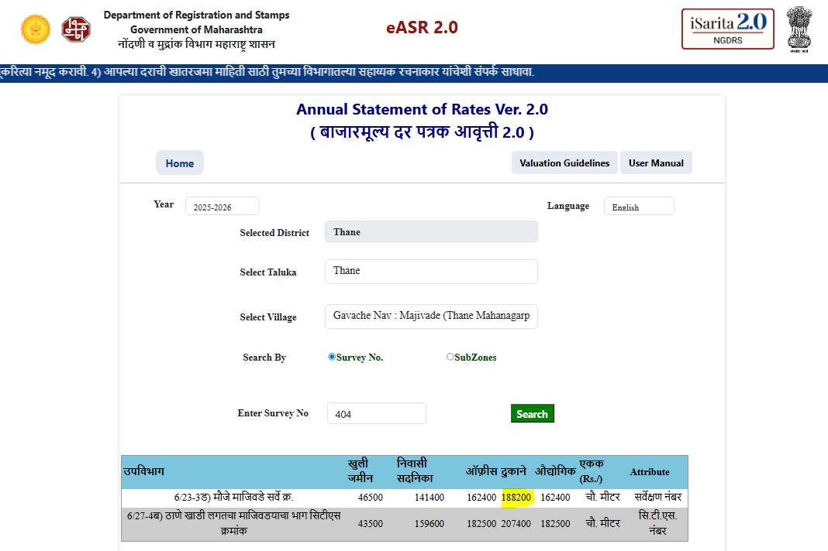

Sales Comparable

